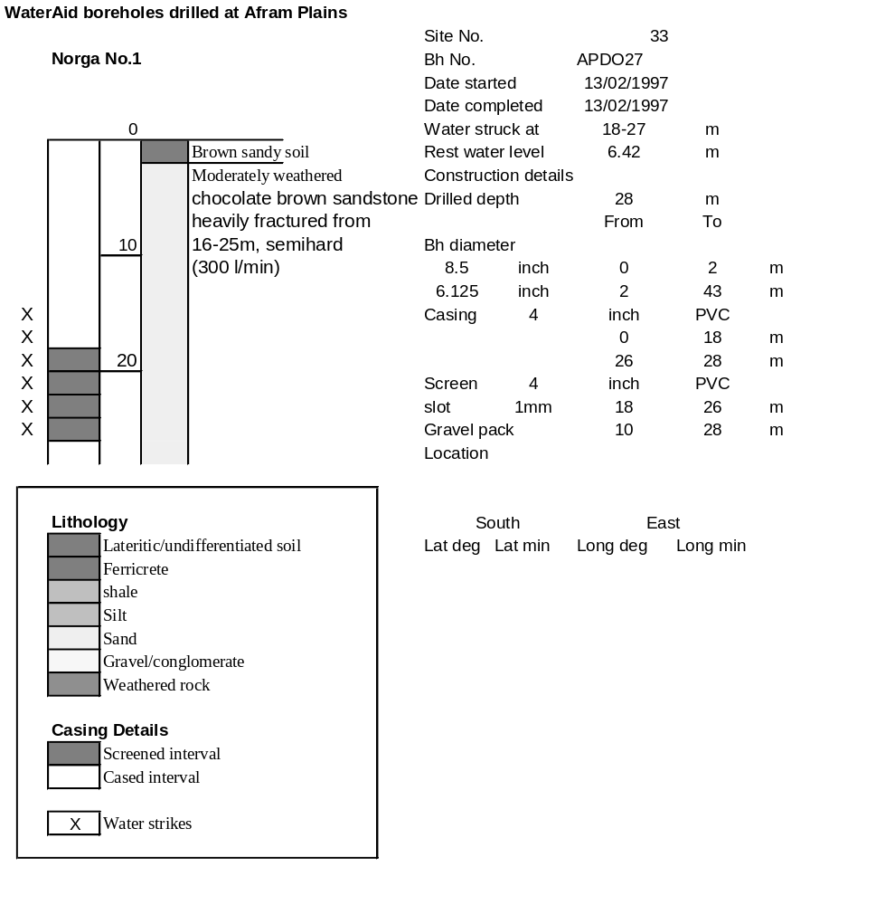

Ghana | Test pumping
Borehole No. |  | APDO 27
Hole No |  | 33
Village |  | Norga No. 2
Date |  | 14/02/1997
Point above GL |  | 0.5 | m
Pump depth |  | 17 | m
SWL |  | 6.42 | m
Start Time |  | 09:25
Drawdown test |  |  |  |  | Recovery Test
time | pwl (m) | Q l/min | dd | sc(q/s) | Time | wl (m) | t/t' | resdd
0.00 | 6.42 | 100.00 | 0.00 |  | 0.00 | 13.38 |  | 6.96
1.00 | 10.32 | 100.00 | 3.90 | 25.64 | 1.00 | 7.24 | 181.00 | 0.82
2.00 | 10.81 | 100.00 | 4.39 | 22.78 | 2.00 | 7.05 | 91.00 | 0.63
3.00 | 10.90 | 100.00 | 4.48 | 22.32 | 3.00 | 6.97 | 61.00 | 0.55
4.00 | 10.92 | 100.00 | 4.50 | 22.22 | 4.00 | 6.94 | 46.00 | 0.52
5.00 | 10.93 | 100.00 | 4.51 | 22.17 | 5.00 | 6.93 | 37.00 | 0.51
6.00 | 10.94 | 100.00 | 4.52 | 22.12 | 6.00 | 6.92 | 31.00 | 0.50
7.00 | 12.20 | 120.00 | 5.78 | 20.76 | 7.00 | 6.90 | 26.71 | 0.48
8.00 | 12.62 | 120.00 | 6.20 | 19.35 | 8.00 | 6.89 | 23.50 | 0.47
9.00 | 12.83 | 120.00 | 6.41 | 18.72 | 9.00 | 6.89 | 21.00 | 0.47
10.00 | 12.94 | 120.00 | 6.52 | 18.40 | 10.00 | 6.89 | 19.00 | 0.47
11.00 | 12.99 | 120.00 | 6.57 | 18.26 | 12.00 | 6.88 | 16.00 | 0.46
12.00 | 13.01 | 120.00 | 6.59 | 18.21 | 14.00 | 6.87 | 13.86 | 0.45
13.00 | 12.99 | 120.00 | 6.57 | 18.26 | 16.00 | 6.87 | 12.25 | 0.45
14.00 | 13.02 | 120.00 | 6.60 | 18.18 | 18.00 | 6.86 | 11.00 | 0.44
15.00 | 13.04 | 120.00 | 6.62 | 18.13 | 20.00 | 6.86 | 10.00 | 0.44
16.00 | 13.05 | 120.00 | 6.63 | 18.10 | 22.00 | 6.85 | 9.18 | 0.43
17.00 | 13.09 | 120.00 | 6.67 | 17.99 | 24.00 | 6.85 | 8.50 | 0.43
18.00 | 13.11 | 120.00 | 6.69 | 17.94 | 26.00 | 6.85 | 7.92 | 0.43
19.00 | 13.19 | 120.00 | 6.77 | 17.73 | 28.00 | 6.84 | 7.43 | 0.42
20.00 | 13.23 | 120.00 | 6.81 | 17.62 | 30.00 | 6.84 | 7.00 | 0.42
22.00 | 13.26 | 120.00 | 6.84 | 17.54 | 35.00 | 6.84 | 6.14 | 0.42
24.00 | 13.19 | 120.00 | 6.77 | 17.73 | 40.00 | 6.83 | 5.50 | 0.41
26.00 | 13.18 | 120.00 | 6.76 | 17.75 | 45.00 | 6.82 | 5.00 | 0.40
28.00 | 13.22 | 120.00 | 6.80 | 17.65 | 50.00 | 6.81 | 4.60 | 0.39
30.00 | 13.30 | 120.00 | 6.88 | 17.44 | 60.00 | 6.80 | 4.00 | 0.38
35.00 | 13.25 | 120.00 | 6.83 | 17.57 | 70.00 | 6.79 | 3.57 | 0.37
40.00 | 13.23 | 120.00 | 6.81 | 17.62 | 80.00 | 6.79 | 3.25 | 0.37
45.00 | 13.23 | 120.00 | 6.81 | 17.62 | 90.00 | 6.78 | 3.00 | 0.36
50.00 | 13.41 | 120.00 | 6.99 | 17.17 | 100.00 | 6.77 | 2.80 | 0.35
55.00 | 13.28 | 120.00 | 6.86 | 17.49 | 110.00 | 6.77 | 2.64 | 0.35
60.00 | 13.26 | 120.00 | 6.84 | 17.54 | 120.00 | 6.77 | 2.50 | 0.35
70.00 | 13.47 | 120.00 | 7.05 | 17.02
80.00 | 13.33 | 120.00 | 6.91 | 17.37
90.00 | 13.35 | 120.00 | 6.93 | 17.32
100.00 | 13.47 | 120.00 | 7.05 | 17.02
110.00 | 13.26 | 120.00 | 6.84 | 17.54
120.00 | 13.40 | 120.00 | 6.98 | 17.19
130.00 | 13.46 | 120.00 | 7.04 | 17.05
140.00 | 13.36 | 120.00 | 6.94 | 17.29
160.00 | 13.33 | 120.00 | 6.91 | 17.37
180.00 | 13.38 | 120.00 | 6.96 | 17.24
